


Develop and update local knowledge
D1.HRS.CL1.06
D1.HOT.CL1.09
D2.TTA.CL2.11
Trainee Manual






Develop and update local knowledge

D1.HRS.CL1.06
D1.HOT.CL1.09
D2.TTA.CL2.11

Trainee Manual





Project Base
William Angliss Institute of TAFE
555 La Trobe Street
Melbourne 3000 Victoria
Telephone: | (03) 9606 2111
Facsimile: | (03) 9670 1330
Acknowledgements
Project Director: | Wayne Crosbie
Chief Writer: | Alan Hickman
Subject Writer: | Alan Hickman
Project Manager/Editor: | Alan Maguire
DTP/Production | Daniel Chee, Mai Vu, Jirayu Thangcharoensamut, Kaly Quach

The Association of Southeast Asian Nations (ASEAN) was established on 8 August 1967. The Member States of the Association are Brunei Darussalam, Cambodia, Indonesia, Lao PDR, Malaysia, Myanmar, Philippines, Singapore, Thailand and Viet Nam.
The ASEAN Secretariat is based in Jakarta, Indonesia.
General Information on ASEAN appears online at the ASEAN Website: www.asean.org.
All text is produced by William Angliss Institute of TAFE for the ASEAN Project on “Toolbox Development for Priority Tourism Labour Division”.
This publication is supported by the Australian Government’s aid program through the ASEAN-Australia Development Cooperation Program Phase II (AADCP II).
Copyright: Association of Southeast Asian Nations (ASEAN) 2012.
All rights reserved.
Disclaimer
Every effort has been made to ensure that this publication is free from errors or omissions. However, you should conduct your own enquiries and seek professional advice before relying on any fact, statement or matter contained in this book. The ASEAN Secretariat and William Angliss Institute of TAFE are not responsible for any injury, loss or damage as a result of material included or omitted from this course. Information in this module is current at the time of publication. Time of publication is indicated in the date stamp at the bottom of each page.
Some images appearing in this resource have been purchased from stock photography suppliers Shutterstock and iStockphoto and other third party copyright owners and as such are non-transferable and non-exclusive. Clip arts, font images and illustrations used are from the Microsoft Office Clip Art and Media Library. Some images have been provided by and are the property of William Angliss Institute.
Additional images have been sourced from Flickr and SXC and are used under Creative Commons licence: http://creativecommons.org/licenses/by/2.0/deed.en

File name: TM_Develop_update_local_knowledge_refined





Table of contents
Introduction to trainee manual 1
Unit descriptor 3
Assessment matrix 5
Glossary 7
Element 1: Develop local knowledge 9
Element 2: Update local knowledge 29
Element 3: Maintain contact with local communities 39
Presentation of written work 59
Recommended reading 61
Trainee evaluation sheet 63
Trainee self-assessment checklist 65

Introduction to trainee manual

To the Trainee
Congratulations on joining this course. This Trainee Manual is one part of a ‘toolbox’ which is a resource provided to trainees, trainers and assessors to help you become competent in various areas of your work.
The ‘toolbox’ consists of three elements:
- A Trainee Manual for you to read and study at home or in class
- A Trainer Guide with Power Point slides to help your Trainer explain the content of the training material and provide class activities to help with practice
- An Assessment Manual which provides your Assessor with oral and written questions and other assessment tasks to establish whether or not you have achieved competency.
The first thing you may notice is that this training program and the information you find in the Trainee Manual seems different to the textbooks you have used previously. This is because the method of instruction and examination is different. The method used is called Competency based training (CBT) and Competency based assessment (CBA). CBT and CBA is the training and assessment system chosen by ASEAN (Association of South-East Asian Nations) to train people to work in the tourism and hospitality industry throughout all the ASEAN member states.
What is the CBT and CBA system and why has it been adopted by ASEAN?
CBT is a way of training that concentrates on what a worker can do or is required to do at work. The aim is of the training is to enable trainees to perform tasks and duties at a standard expected by employers. CBT seeks to develop the skills, knowledge and attitudes (or recognise the ones the trainee already possesses) to achieve the required competency standard. ASEAN has adopted the CBT/CBA training system as it is able to produce the type of worker that industry is looking for and this therefore increases trainees chances of obtaining employment.
CBA involves collecting evidence and making a judgement of the extent to which a worker can perform his/her duties at the required competency standard. Where a trainee can already demonstrate a degree of competency, either due to prior training or work experience, a process of ‘Recognition of Prior Learning’ (RPL) is available to trainees to recognise this. Please speak to your trainer about RPL if you think this applies to you.
What is a competency standard?
Competency standards are descriptions of the skills and knowledge required to perform a task or activity at the level of a required standard.
242 competency standards for the tourism and hospitality industries throughout the ASEAN region have been developed to cover all the knowledge, skills and attitudes required to work in the following occupational areas:
- Housekeeping
- Food Production
- Food and Beverage Service
- Front Office
- Travel Agencies
- Tour Operations.
All of these competency standards are available for you to look at. In fact you will find a summary of each one at the beginning of each Trainee Manual under the heading ‘Unit Descriptor’. The unit descriptor describes the content of the unit you will be studying in the Trainee Manual and provides a table of contents which are divided up into ‘Elements’ and ‘Performance Criteria”. An element is a description of one aspect of what has to be achieved in the workplace. The ‘Performance Criteria’ below each element details the level of performance that needs to be demonstrated to be declared competent.
There are other components of the competency standard:
- Unit Title: statement about what is to be done in the workplace
- Unit Number: unique number identifying the particular competency
- Nominal hours: number of classroom or practical hours usually needed to complete the competency. We call them ‘nominal’ hours because they can vary e.g. sometimes it will take an individual less time to complete a unit of competency because he/she has prior knowledge or work experience in that area.
The final heading you will see before you start reading the Trainee Manual is the ‘Assessment Matrix’. Competency based assessment requires trainees to be assessed in at least 2 – 3 different ways, one of which must be practical. This section outlines three ways assessment can be carried out and includes work projects, written questions and oral questions. The matrix is designed to show you which performance criteria will be assessed and how they will be assessed. Your trainer and/or assessor may also use other assessment methods including ‘Observation Checklist’ and ‘Third Party Statement’. An observation checklist is a way of recording how you perform at work and a third party statement is a statement by a supervisor or employer about the degree of competence they believe you have achieved. This can be based on observing your workplace performance, inspecting your work or gaining feedback from fellow workers.
Your trainer and/or assessor may use other methods to assess you such as:
- Journals
- Oral presentations
- Role plays
- Log books
- Group projects
- Practical demonstrations.
Remember your trainer is there to help you succeed and become competent. Please feel free to ask him or her for more explanation of what you have just read and of what is expected from you and best wishes for your future studies and future career in tourism and hospitality.

Unit descriptor
Develop and update local knowledge
This unit deals with the skills and knowledge required to Develop and update local knowledge in a range of settings within the hotel and travel industries workplace context.
Unit Code:
D1.HRS.CL1.06
D1.HOT.CL1.09
D2.TTA.CL2.11
Nominal Hours:
30 hours

Element 1: Develop local knowledge
Performance Criteria
1.1 Identify and access sources for information on the local area, correctly
1.2 Identify and obtain information to assist queries on local/national tourism industry, correctly
1.3 Store and update information according to enterprise procedures
1.4 Share information with colleagues

Element 2: Update local knowledge
Performance Criteria
2.1 Use informal and/or formal research to update local knowledge
2.2 Share updated knowledge with customers and colleagues, as appropriate
2.3 Incorporate the sharing of local knowledge into day to day working activities

Element 3: Maintain contact with local communities
Performance Criteria
3.1 Provide accurate local tourism information in response to queries
3.2 Use local knowledge to promote tourism products and services to encourage usage and purchase
3.3 Make customers aware of possible extras, add-ons and further benefits
3.4 Report queries and results to designated person within enterprise for follow-up purposes

Assessment matrix
Showing mapping of Performance Criteria against Work Projects, Written Questions and Oral Questions
The Assessment Matrix indicates three of the most common assessment activities your Assessor may use to assess your understanding of the content of this manual and your performance - Work Projects, Written Questions and Oral Questions. It also indicates where you can find the subject content related to these assessment activities in the Trainee Manual (i.e. under which element or performance criteria). As explained in the Introduction, however, the assessors are free to choose which assessment activities are most suitable to best capture evidence of competency as they deem appropriate for individual students.
 |  |  | Work Projects | Written Questions | Oral Questions
Element 1: Develop local knowledge
1.1 | Identify and access sources for information on the local area, correctly |  | 1.1 | 1, 2, 3, 4 | 1
1.2 | Identify and obtain information to assist queries on local/national tourism industry, correctly |  | 1.1 | 5, 6, 7, 8 | 2
1.3 | Store and update information according to enterprise procedures |  | 1.2 | 9, 10 | 3
1.4 | Share information with colleagues |  | 1.2 | 11 | 4
Element 2: Update local knowledge
2.1 |  | Use informal and/or formal research to update local knowledge | 2.1 | 12, 13 | 5
2.2 |  | Share updated knowledge with customers and colleagues, as appropriate | 1.2, 2.2 | 14 | 6
2.3 |  | Incorporate the sharing of local knowledge into day to day working activities | 2.3 | 15, 16, 17 | 7
Element 3: Maintain contact with local communities
3.1 | Provide accurate local tourism information in response to queries |  | 3.1 | 18, 19, 20, 21 | 8
3.2 | Use local knowledge to promote tourism products and services to encourage usage and purchase |  | 3.1 | 22, 23, 24 | 9
3.3 | Make customers aware of possible extras, add-ons and further benefits |  | 3.1 | 25, 26, 27 | 10
3.4 | Report queries and results to designated person within enterprise for follow-up purposes |  | 3.2 | 28, 29, 30 | 11

Glossary
Term | Explanation
ATM | Automatic Teller Machines
CBD | Central Business District
CRS | Computerised Reservation system
Concierge | A person/desk at an accommodation venue providing local advice and information to visitors/tourists about a wide variety of things such as restaurants, directions on how to get to places, shops, customers, trips and tours
Cons | Confidence tricks – attempts by people to defraud other people
Cuisine | A style of cooking
Display adverts | Display advertisements: advertisements in telephone books or newspapers containing graphics and ‘extra’ information about a business such as the products, services and facilities they provide, prices they charge, and credit cards they accept
EFTPOS | Electronic Funds Transfer at Point of Sale
E-Magazine | An electronic magazine downloadable from a website: may be free of charge or may require payment of a fee
Familiarisations | Also known as ‘famils’ or ‘fam tours’ are free-of-charge visits to venues, parks, attractions and destinations so people can experience first-hand what the venue is like so they can tell others (or make a buying decision)
Fauna | The animals of a country or region: the wildlife of an area
Flora | The flowers and plants of a country or region: plant life of an area
Flyer | An advertising handout
Front-of-house staff | Any staff who work ‘front-of-house’- that is, they have face-to-face contact with customers/guests
Generic information | Information that is generally applicable
IT | Information Technology
Industry knowledge | Generic information on the tourism/hospitality industry such as knowledge about competitors in the industry, support services, and visitor information about the local area, region or country
Infrastructure | The facilities and services supporting and enabling the functioning of a country/region such as its transport system, hospitals, schools and power utilities
Local attractions | Natural or man-made sites that visitors may want to visit
MICE | Meetings, Incentives, Conventions, Exhibitions
Product knowledge | Knowledge about the venue where you work including knowledge about products sold, services provided and the policies, procedures and protocols guiding the operation of the property

Element 1:
Develop local knowledge

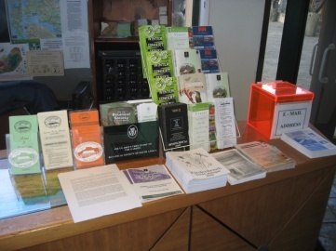
1.1 Identify and access sources for information on the local area, correctly

Introduction
Industry and product knowledge are vital pre-requisites for effective performance within the industry.
This section identifies where information can be obtained enabling you to develop local knowledge that can be passed on to customers/guests.

The importance of local knowledge
It is important for you to have local knowledge about your venue, town, region or country so you can:
- Pass this on to tourists/visitors – and enhance their experience
- Inform tourists/visitors about what is happening locally and convince them to spend more time (and money) in your area which will help create more jobs and generate even more tourism
- Meet tourist/visitor expectation. Tourists/visitors expect staff at a venue to be able to advise them about local events and attractions.

Information topics
When developing local knowledge you should aim to capture information on the following:
- General information on the tourism industry
- Local tourism destinations, facilities and infrastructure
- Tourism products including tourism services, facilities and rates
- Environmental issues including eco-tourism
- Local attractions, tours, events and places of interest
- Local customs. This can include information about what visitors should not say or do, and information about local food and drinks.
Section 1.2 will provide more details on what should be obtained for each of the above.
There are many sources of information available to help you develop your local knowledge.
Some of these sources are generic in nature and others are specific to one industry and/or to a specific industry sector.
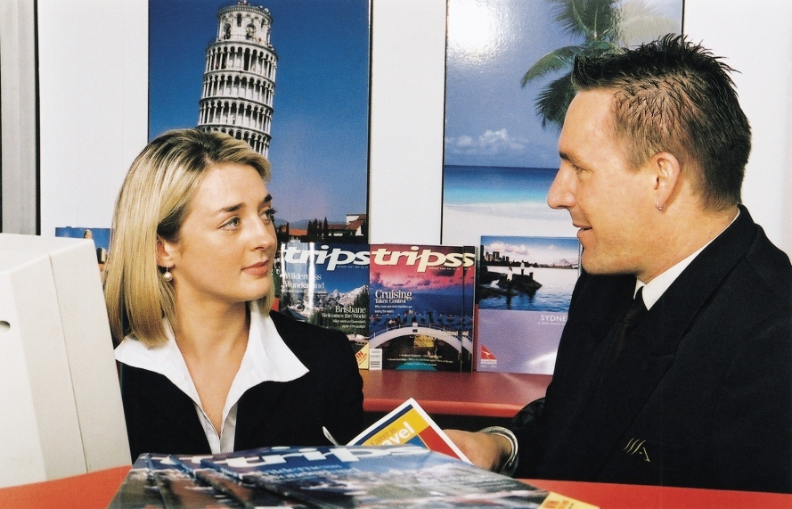
Some are easy to access and some require more dedication, time and effort. Some may even have a cost associated with them.

Visitor Information Centres
This is probably the first contact you should make when seeking to develop local knowledge.
Visitor Information Centres are ready-made sources of valuable and useful local information. They will have done much of the hard work in gathering together much of the information you need.
The information is all there – all you have to do is ask for it.
Gather whatever information they have available. There are often invaluable lists of local government services and contacts, as well as stacks of brochures about hire cars, flyers about local tourist attractions, booklets about local tours, local visitor and attraction guides.
This amazing source is definitely not to be under-estimated. Spend some time getting to know the manager and the counter/visitor contact staff making them aware that you and your organization is committed to getting tourists to spend as much time as possible locally.
This means you and the information centre are allies, both working towards the same goal. The goal is to maximise visitor nights and visitor expenditure in the local area.
A good working relationship with these people is essential to encourage them to feed you with any up-to-date information they become aware of. Go and meet whoever the manager is, have a beverage with them or invite them to your venue for a drink. Get to know them!

The Visitor Information Centre will have undertaken an audit of the venues, hotels, restaurants, bars, shops, tourist attractions and tours in your area and will be well equipped to pass this information on to you.
Their audit will have classified local offerings into various categories - or 'cells' - (such as 'national parks', 'man-made attractions') and these classifications may be useful to you when constructing your resource file (see Section 1.3).
Certainly the quality of service you can expect from these centres is outstanding. Many have been through an accreditation process with their peak body and actively strive not only to provide information to visitors and tourists, but to provide underpinning support to industry as well.
In addition, many of these visitor centres are sites you and all the other establishment staff should visit occasionally in order to get to know what is on offer there. The visitor centre itself can be a place where you send visitors, not as a source of obtaining information, but in order to see the various displays they have on show.
These displays can vary over time, with many centres boasting substantial and attractive, permanent displays (many of which are interactive to some degree). These static displays are supplemented from time to time by temporary displays featuring some particular local aspect. This can be historical, geographical, geological, festival or event-related.
Some centres even have a theatre facility where tourists can usually view free of charge a video about the local area. The people you send there will appreciate you providing them with this sort of advice and genuine 'local knowledge'.
Get involved
Finally, you and your venue should get involved.
This means ensuring your establishment belongs to the local 'tourism promotion' board, or whatever the local equivalent is.

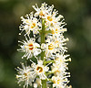
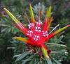
You and your premises should support local events (perhaps by contributing a night's accommodation, or a meal), and you or one of your staff should attend local events and happenings such as new product launches, local initiatives, local openings and local functions in general.
Not only does doing this keep you abreast of what's happening but it helps to keep you up to date with what is happening and keeps your organisation in everyone's mind (by virtue of the 'in sight, in mind' principle) thus helping to make your organization a good corporate citizen too.

Written material
There are numerous examples of written material available to access local knowledge and information:
- Reference books on the country, region or specific aspects of the country (such as its flora and fauna, its history and customs, famous people, trade details, plans for the area/country)
- Trade magazines which may be purchased from newsagents or obtained via subscription. These detail events within the industry and are an excellent source of local, national and global information
- Trade magazines can focus on sectors of the industry (such as food and beverage, housekeeping, bars, MICE, spas) and/or provide generic information on, for example, travel, tourism or hospitality
- Visit the following for an indication of the publications available:
- http://www.media-directory.asia/magazine/business-magazines/hotel-hospitality-business/singapore/c-1874
- http://www.traveldailyasia.com/LocalNews/Singapore.aspx
- http://hotelresource.tradepub.com/
- http://www.travelandleisure.com/
- http://ehotelier.com/directory/?magazines-books

- Guidebooks. Numerous guidebooks exist on every major tourist destination or country.
While these are often read by tourists to help them obtain a ‘feel’ for the country they are visiting, they can also be useful to staff working in those countries as a reference and resource.
Many guidebooks are available online as free downloads, or can be purchased online.
For professionals in the tourist industry it is always worthwhile to get an idea of what tourists expect when they visit us, so obtaining a few of these guides and browsing through them can be a very educational and rewarding experience


- Newspapers. Many large circulation newspapers feature some aspect of the travel, tourism and hospitality industries on a regular basis. These features can include:
- Food and drink reviews of restaurants, dining rooms, certain dishes, nominated cuisines, bars, drink types, wines
- Industry movements i.e. identifying staff who are moving between properties, identifying ownership of venues and the companies buying and selling properties, identifying new properties coming into the marketplace as well as venues undergoing renovations and refurbishment and venues closing their doors
- Travel articles. These describe travel experiences of correspondents, travel destinations and tourist attractions and explain how to travel between destinations while discussing different travel and transportation options
- Issues of interest. These may include coverage of a wide range of topics impacting on the industry such as taxation, impact of events locally and internationally, effect of currency fluctuations on inbound and outbound tourists/visitors plus industry trends and new products and services
- Most newspapers carry these articles in their pages on the same day each week. Find out the days these features appear and take the time to read them
- The telephone book. Where ‘display adverts’ are used the local telephone book can provide much valuable information about local businesses and your local competition (such as products, facilities and services available, star rating, location relative to other attractions, credit cards accepted, affiliations with clubs, groups or other organizations)
- Libraries. Where you have access to public libraries they are a great source of material you do not have to pay for. Your local library can often also arrange inter-library loans

- Brochures. Most suppliers and service support industries (local council, authorities, competitors) provide various forms of printed information that can assist with information in relation to:
- Product information – for example, the products available at a shop, venue, attraction or destination
- Services provided at the location to which the brochure applies
- Contact details for their business to which the brochure applies – the telephone number, street address, web details and other information including hours of operation, credit cards accepted
- Maps of the local district
- Advertisements whether in the newspaper or in other formats (brochures, flyers, guide books). These are an excellent source of information about other venues in the industry, new products and services, prices, special deals and offers.

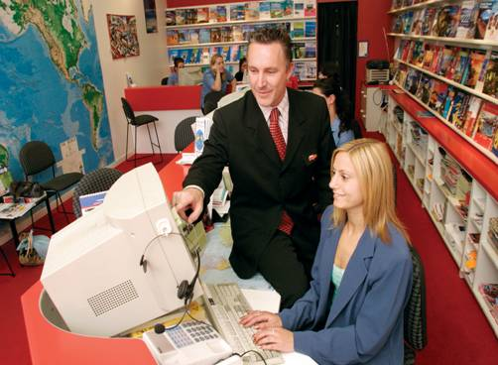
Internet
Some of the above ‘written material’ sources can also be internet-based but the internet is a great source of much more local information and knowledge.
You should develop a list of ‘Favourite’ websites and ‘Bookmark’ them for ready reference.
These websites might include local:
- Tour and travel operators – especially those who provide local (one-day, half-day) tours such as bus trips, drive-yourself, small groups
- Shops – especially of shops for which the local area is famous. For example, some destinations are famous for jewellery, some for electronic goods and others for clothing and fashion
- Suppliers – food, beverages, other supplies, equipment
- Industry associations – peak industry bodies, and industry representative organizations
- Government bodies – liquor, gaming, food safety, occupational safety and health, and tobacco agencies
- Venues. These should be properties similar to the one where you are working so you can compare what similar venues advertise, offer or do
- Attractions – the natural and man-made attractions in the local area.
Online newsletters
It is worth subscribing to any information services or newsletters offered from relevant businesses or organizations as they are usually free.
These are usually provided in electronic format and produced by industry suppliers and support services and made available as a marketing tool. They commonly contain a significant advertising component (which in itself can be useful), but they also can contain many useful gems to develop your industry, product and local knowledge.

Visit and subscribe to the following, as appropriate:
- http://www.thetravelmagazine.net/cy-4-86--east-southeast-asia--singapore.html
- https://app.stb.gov.sg/asp/index.asp
- http://www.filipinotravel.com.ph/corporate/newsletter.php
- http://www.traveldojo.com/brunei/
- http://www.indochinatravelservice.com/newsletter/.
To identify more newsletters do a search for ‘<Name of country> travel newsletter’.
Online links
Be alert to the links on each site you visit to identify options relevant for your geographic location and/or industry type/sector. For example:
http://www.traveldailyasia.com/LocalNews/Malaysia.aspx is a link from http://www.traveldailyasia.com/LocalNews/Singapore.aspx.


Local associations
Many regions, towns and cities have established a ‘tourism’ association and/or local Chamber of Commerce (or similar).
These are invaluable in terms of:
- Providing contacts for you to use when developing your individual industry network – see below
- Supplying information about local businesses and the products and services they provide
- Bringing local businesses together in a supportive and mutually beneficial environment.
These associations will meet regularly and it is important for you or your venue to attend these meetings to:
- Meet like-minded people and demonstrate your interest in the industry and the local area
- Participate in discussions which will ultimately have some impact on your workplace
- Contribute ideas which will benefit your venue and the local area or economy.

Developing an industry network
‘Networking’ is a great way of learning about many industry-related topics.
To develop a useful network of contacts you will need to make deliberate attempts to target and talk to people you respect within targeted aspects of the industry you work in.
For example, you may decide it is important to develop a relationship (a network) with:
- Someone from the local tour business
- A person in an opposition venue in town
- The manager of the Visitor Information Centre
- Staff at local attractions.
You should start forming an industry network of contacts at the earliest opportunity. The network will definitely help you in your work and provide information about what is happening elsewhere in the industry or local area.
The network of contacts can also be very useful in other work-related areas such as possible employment opportunities.
Remember you have to make the effort to create (and maintain) the network. You cannot rely on others contacting you and initiating the contact or network.
After you have made initial contact with these people you must keep in contact with them:
- You need to contact your contacts or network when you find out something you think they might like to know. This highlights the two-way nature of the concept of networking
- You need to occasionally contact them just to ‘stay in touch’ even when there is nothing specific to pass on to them. Often they remember something they need to tell you when you make contact and your call demonstrates you value them as a contact.

1.2 Identify and obtain information to assist queries on local/national tourism industry, correctly

Introduction
It is not sufficient that you ‘work in the industry’ in order to gain necessary local and national knowledge, you must also take action to obtain current, comprehensive and accurate information.
The key to obtaining information is for you to be proactive. You have to go and find the information, then obtain copies of what is available.
Efforts must be made to capture local and national tourism information.

How to obtain information
Obtaining the information you need is a matter of applying yourself to the sources identified in the previous section.
In practice this can mean:
- Subscribing to, and reading, industry magazines, updates, fact sheets, reports and research findings
- Reading through local and city newspapers – especially those sections carrying articles on hospitality, travel and tourism, events, festivals and attractions

- Visiting the Visitor Information Centre and meeting the manager and staff and collecting brochures and advertising material.
You will need to obtain multiple copies of brochures and other materials so you can place them in your display area (reception, concierge, the foyer area) so they can be given to visitors and guests

- Surfing the internet:
- Viewing websites/pages
- Downloading, saving, bookmarking or printing relevant information/sites
- Registering on e-mail lists to receive newsletters and updates from relevant industry government agencies, suppliers and/or support services
- Downloading E-Mags relevant to your industry sector. Many of these are free of charge but some require payment
- Joining your local industry association and taking an active interest in the issues foremost in their minds by participating in discussions, meetings and research
- Reading books. You should aim to read widely and include local, regional and national books
- Being a tourist yourself in your local area. This involves getting out and having a look around to see what is happening, what people are doing, what the competition is doing, and what people are saying.
Get a hard copy
For every piece of information you identify, you should ensure you obtain a hard copy version of the information so it can be filed for later use and/or given to anyone wanting such information.
You will forget most of what you manage to find if you do not get a hard copy and store it on file for later use or retrieval.
If you cannot obtain a hard copy, write the information down so it can be converted into a permanent form at a later date.

Types of information required
When identifying and obtaining information, effort must be taken to capture knowledge about the following:
General information on the tourism industry
This could include gaining information on the following topics:
- Numbers of inbound tourists and any trends (such as, for example, whether numbers are increasing or decreasing and to what extent)
- Reasons for their visits – business, visiting relatives, tourism
- Amount spent on a per head and per night basis
- Countries of origin – determining the 10 most popular countries from which overseas visitors/tourists come
- Most popular times of the year for travel – festivals, religious events, holiday periods, seasonal influences
- Method of travel – identifying the percentages who travel by air, road, train, sea and other means to come to the country.
Local tourism destinations, facilities and infrastructure
This could include:
- Identification of local tourism destinations such as towns, villages, lakes and rivers tourists could be expected to visit. Within these destinations there may be ‘attractions’ (see below).
For local destinations you need to determine:
- Route to the destination including options, where applicable
- Distances
- Opening hours
- Cost, if any, to visit
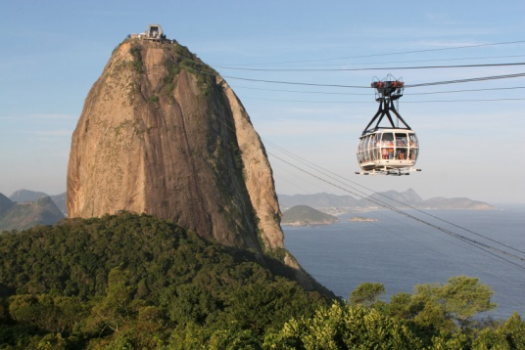
- Identification of local facilities for tourists such as toilets, medical facilities/hospitals, baby care/changing facilities, disabled facilities, Visitor Information Centres, money exchanges, police stations, embassies
For local facilities you need to determine:
- Locations and routes from your workplace to them
- Time to travel
- Opening times
- Fees charged, where applicable, for services rendered
- Contact details – telephone numbers, websites
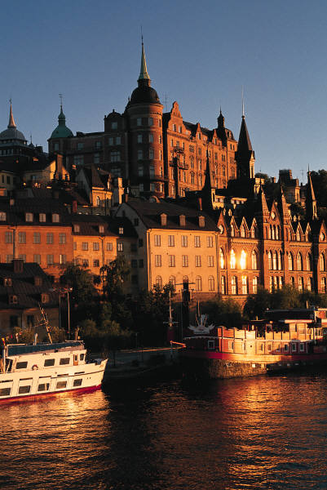
- Identification of local infrastructure supporting tourism such as local rail services, transportation terminals, ferry services, buses, taxis, domestic airlines and/or charter services.
In some cases transport infrastructure can extend into an ‘attraction’ or ‘service’ in its own right. For example, tourists may visit an area purposely to experience:
- Hot air balloon travel
- Elephant or camel rides
- Houseboats
- All-terrain vehicles
- Trishaws
For transport services you need to determine:
- Locations of airports, train stations, bus depots/stops
- Routes to each service
- Timetables
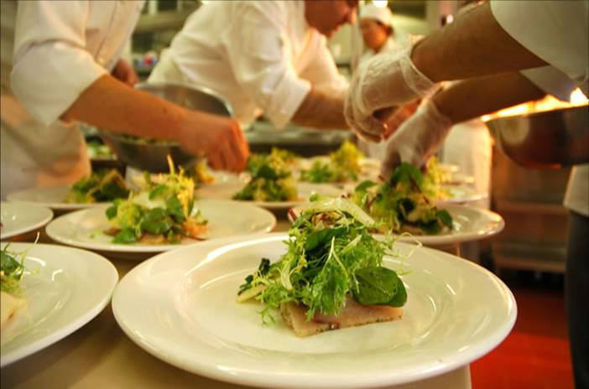
- Cost for travel/tickets including taxi rates
- Where and how to buy tickets.
Tourism products
This could include:
- Places to:
- Stay – accommodation options available locally including hotels (of different ratings) and backpacker accommodation. Attention should also be paid to identifying any eco-friendly accommodation venues
- Eat – covering the differing dining options from eat-in (fine dining to more modest establishments), different cuisine types, street stalls/vendors and fast-food outlets
- Drink – bars and locations for buying take-out liquor

- Services, such as:
- Hire cars
- Money exchanges and banks
- Secretarial services for business visitors
- Dry cleaning and laundry
- Security
- Immigration advice
- Emergency services
- In-house services available to guests at a venue/hotel
- Facilities, taking into account:
- In-house facilities for guests – spa, swimming pool, gymnasium, business centre, internet connection
- Local facilities as identified above: toilets, disabled access, wheelchair ramps, parking, transportation, arts centres
- Rates. This is a very big area and one subject to on-going change.
‘Rates’ refers to the prices charged by providers for the products and services they provide.
Rates include:
- Room rates for accommodation; single, double, and family, taking into account any allowable discount
- Fees to enter an amusement or theme park and/or the cost of tickets and rides
- Fees for travelling on cable cars, trains, buses, taxis, ferries and other local transport options
- Exchange rates for changing money between currencies

- Charges made by businesses for products sold and services rendered such as exchanging money, meals, shopping
- Taxations rates and identification of goods and/or services they apply to plus any refunds or rebates international visitors may be entitled to when they leave the country.
Environmental issues
The nature of the information you will require in this regard will vary greatly depending on the geographical location of your workplace.
Information you could need to capture includes:
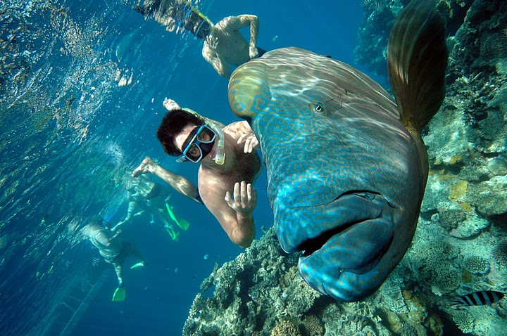
- Weather and the seasons: when it is likely to be hot, cold, wet, windy or other as appropriate to the individual location
- Tides – especially where tourism focuses on boating and fishing
- Times of sunrise and sunsets
- Regional variations in weather – such as identification of micro-climatic conditions for certain areas/locales
- Items deemed to be ‘at risk’ – flora and fauna
- Sustainable features of the local area/region
- Options available for visitors seeking an eco-tourism experience.
Local attractions, tours, events and places of interest
This could include:
- Natural attractions – such as caves, mountains, the ocean, sea, gorges, sanctuaries, gardens, waterways
- Man-made attractions (also known as ‘built attractions’) – entertainment centres, amusement parks, theme parks, lookouts, science centres, museums
- Buildings – ancient buildings and ruins, government buildings, buildings with historic significance, former prisons and dwellings
- Tours. These may be:
- Time-based – 2-hour, half-day, full-day, multiple days
- Subject-based. These may focus on:
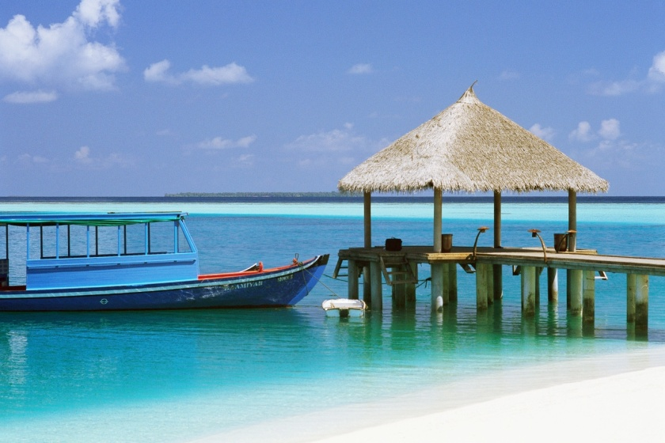
- Sports tourism
- Landmarks
- Food tourism
- Cultural tourism
- Eco-tourism
- Religious tourism
- Arts

- Area-based focusing on, for example:
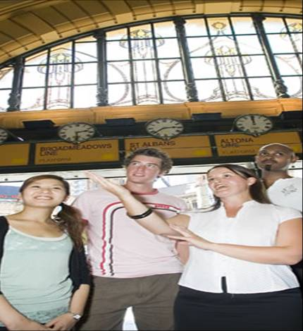
- A town, city or region – a general tour visiting landmarks and other ‘places of interest’ (see below)
- The Central Business District of a city
- Shopping precincts
- Events. These relate to special occasions conducted in an area and can include:
- Sporting events
- Religious observances and festivals
- Meetings, Incentives, Conventions, Exhibitions (MICE) occurring in the area
- Local and national celebrations
- Some local areas prepare a ‘Calendar of Festivals and Events’ detailing the upcoming events for the next 12 months
- Places of interest. This phrase can include almost anything including the already mentioned built attractions, landmarks and ruins, plus natural attractions. It can also cover:
- Sites of historic battles
- Unique architecture
- Groups of ethnic people and their houses, shops and religious shrines
- Squares, show grounds and theatres
- Geographical features, fossils and forests
- Local dangers. Attention must always be paid to ensuring visitors are provided with appropriate advice regarding any local dangers they may be subjected to, for example:
- Wild animals
- Currents and tides
- Areas, locations and neighbourhoods they should avoid because of the potential for attack – the ‘no go’ areas
- Geographical features with the potential to cause death/injury
- Activities that may be inappropriate given the profile of the visitor. For example, a walking trail may be suitable for a young and fit tourist but totally inappropriate for a frail and elderly person
- Weather conditions – rain, sun, wind.


Local customs
This could include information relating to:
- Dress – what to wear, what not to wear, requirements regarding footwear and covering parts of the body
- Language – providing basic words or phrases such as ‘Yes’, ‘No’, ‘Hello’
- Personal behaviour. This may address:
- Eye contact and other non-verbal communication issues
- Shaking of hands when meeting and greeting a person
- Local activities related to certain events, circumstances and/or geographic factors
- Legal issues – identifying what offences are provided for under relevant legislation
- Accepted protocols – identifying acceptable, unacceptable and expected actions related to nominated occurrences, events, meetings, circumstances and normal daily life.

1.3 Store and update information according to enterprise procedures

Introduction
Once the relevant local information has been sourced, it must be stored for future use as deemed most appropriate by the enterprise, in keeping with any relevant policies and procedures.

Storing information
Enterprise requirements and procedures
Enterprise requirements and procedures will address:
- The type, style and nature of the storage and retrieval system to be used – see below
- The type, style, nature, size and location of the information display and/or file which will usually embrace:
- Where brochures will be displayed to the public so they can ‘help themselves’ to brochures (such as in the foyer area)
- The materials to be placed in guest rooms in the compendiums, on side-tables and on service counters
- Information supplied to guests when on arrival
- Identification of personnel with responsibility for:
- Capturing initial information, brochures, price lists, maps, flyers and promotional material from local and other attractions and venues
- Updating the information brochures to ensure it remains current providing up to date materials, prices, opening times and explanations of shows, events or displays
- Entering new or revised information into an electronic system
- Maintaining the display to keep it looking neat and tidy and to remove soiled, torn materials
- Maintaining the store of materials to ensure the display never runs out of brochures and materials
- Identification of who is authorised to attend meetings to capture local information about upcoming events and to participate with others (venues, authorities, attractions) to attract visitors to the local area.
Storage options
Every business must decide how and where to keep the ‘visitor information’ they have gathered, and will continue to gather.
Options are several, but a simple and basic system tends to be preferred over a technical one. Computer based 'data retrieval systems' tend not to be customer-friendly and there is always the risk that not every staff member will be able to use them.
In addition, if an electronic system is used, someone has to enter the information in the first place. This is a time consuming and expensive undertaking.
(Note: many computerised reservation system [CRS] incorporate, or are integrated with databases providing local tourism information.)
Some form of filing system – often kept behind the front office/reception area - coupled with a public area display. A simple assortment of brochures from local venues and attractions will usually suffice.
The glossy brochures, maps and flyers can be kept in the public display and the more detailed, and less frequently requested information, can be kept in the file.
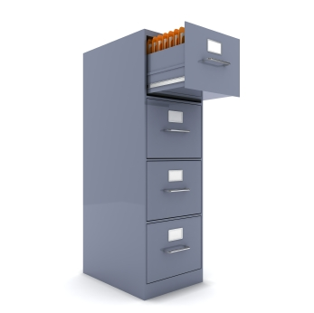
Filing cabinets
The nature of the file to be used to store the information will be an individual choice, but a filing cabinet drawer is a simple yet effective option. Where this option is used make sure whoever is at reception can access these drawers. There is little point in the information being locked up where staff are unable to get to it.
Suspension files – with manila folders inserted – can be used to divide the drawer up. You can decide on the way you divide the information up, with traditional options including:
- Alphabetical order. This option sounds good but is often unworkable (where do you file information about a theme park called ‘Excitement City’? Under ‘T’ for theme park? Under ‘A’ for Amusement Park? Under ‘E’ for ‘Excitement’?) for most things apart from shops
General categories. These are more effective. Classification of categories might include 'medical', 'hire cars', 'man-made tourist attractions', 'natural attractions', 'local government', and so on.
The display area
The public area where local information is displayed may contain a carousel display and/or wall racks containing pamphlets.
It is vital to make sure the public area displays are kept well-stocked, neat and tidy as well as up to date.
Many establishments supply tables and chairs near this facility sometimes with newspapers and magazines to encourage guests to browse and select whatever material they require.
You may elect to include a sign encouraging guests to browse and take what they want. Some people can be self-conscious about taking these items.
A large, easy to read local map sited on the wall is also an excellent idea. There should also be an easy to read take away map of the local area too.
It is also a good idea to have an obvious sign in this location advising guests further information is available at the reception desk, or by contacting a certain person or concierge. The key is to encourage people to use the information you have obtained and supplied.
A primary aim of supplying all these facts and all this advice is to:
- Convince the guest to stay for at least an extra day
- Maximise the enjoyment the guest gets from their stay so they will tell others and bring us referral business.

Doing these things also makes the venue a good, local citizen because it brings extra money into the area, region or city and demonstrates how the business is working to support the local economy.

Updating information
Obtaining updated information
Keys in obtaining updates to local information so they can be made available for provision to guests/visitors are:
- Continue to do the activities initially undertaken to capture local information in the first instance, for example:
- Visit the Visitors Information Centre
- Attend local meetings
- Visit other venues and local attractions
- Read local newspapers, magazines, books
- Obtain materials/information for new venues, attractions and destinations. From time to time new businesses and attractions will open and you need to be proactive in sourcing information from these to pass on to visitors/guests
- Reading alerts, updates, emails and newsletters you have registered to receive as these are often sources of new or revised information

- Picking up any copies of new tourist/visitor information you find in your normal day to day work and other activities and arranging to obtain multiple copies
- Use your network of contacts. Can they advise of any new materials/information? Any changes/updates?
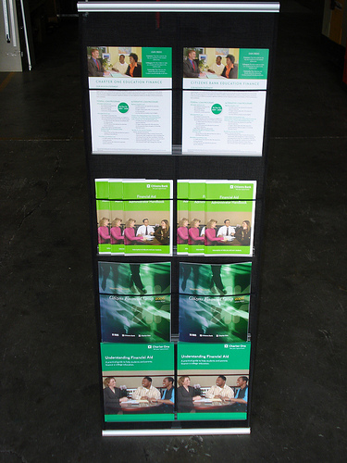
Processing updated information
When processing updated information the following may apply:
- Access the CRS or other dedicated electronic database and add, delete or amend files and fields as necessary
- Access the filing system for hard copy materials and:
- Remove and discard previous versions of materials which will now be out of date due to the new or revised materials
- Replace with the new materials
- Remove out of date materials from the display stands and racks and replace with new or revised materials
- Go to each guest room in the venue:
- Remove out of date materials from the in-room compendium, side-tables and service counters
- Replace with new or revised materials
- Meet with Concierge and:
- Advise of new/revised materials
- Provide several hard copies to the Concierge who will then update their own files or database at their desk.
Important elements
When processing updated local/visitor information, it is important to:
- Thank the person, business, authority or body who provided the updated material. This acknowledges their effort and encourages them to keep sending new and updated materials
- Act on new/revised information immediately. The day the material is received should be the day the old material is replaced with the new material
- Discard all out of date materials. Never leave it lying around the place. It may inadvertently be used to provide incorrect advice or information to guests. Shred the old materials or dispose of them in the trash or recycling bin.

1.4 Share information with colleagues

Introduction
When you have managed to gather and update local information you must be prepared to share such information with work colleagues and incorporate it into your day to day work activities.
This section identifies how local information may be shared with colleagues and Section 2.2 addresses how it might be shared with customers.
Remember: ‘Knowledge is power’ but only if you actually use the knowledge.


Sharing information
The basic ways to share new and/or revised (updated) information with fellow employees are to:
- Verbally tell your colleagues about what you have learned:
- On a one to one basis
- At staff briefings
- At staff meetings
- E-mail co-workers with the information you have discovered attaching relevant information as applicable
- Prepare a short handout. Put this:
- On the staff notice boards
- Hand-deliver it explaining it at the time you hand it out
- In wages envelopes
- In the internal newsletter
- Update the internal systems such as CRS, described in the previous Section
- Replace and replenish internal displays and/or information points with new or revised materials – also described in the previous Section.
Other points to note
Other ways of informing staff/colleagues
Extra ways to advise staff/colleagues about new/revised local information can be to:
- Arrange for a guest speaker from the venue/attraction to come and talk to staff –explaining the venue/attractions, providing sample items, bringing promotional materials
- Arrange for a speaker from the Visitor Information Centre to attend and make a formal presentation to venue staff

- Arrange for staff to visit the venue/attraction personally so they can gain first-hand experience of the venue/attraction. Management at attractions usually provide free entry to their site/venue for staff in the hospitality business knowing there is the potential for ‘referrals’ from these people. Ask your Manager to arrange the visit, and free entry is almost guaranteed.
Selling the reasons for providing information to visitors/guests
When informing other staff/colleagues about new or updated local information you should ensure:
- You are enthusiastic when providing local information to other staff at the venue. Your enthusiasm can be contagious. Unfortunately if you are not enthusiastic, this too is contagious
- You sell the benefits of providing up to date, accurate local information to visitors and guests. These include:
- Increased guest satisfaction with their stay leading to:
- Repeat business from them. They are more likely to return at a later date and spend more time and money in your venue and in the local area
- ‘Referral’ business as they tell their friends and family and encourage them to refer them to your venue for accommodation, meals, rides, sightseeing and other activities
- Very real chance of guests/visitors spending an extra night in the area or at the venue leading to greater financial prosperity for the venue and area
- More secure employment at the venue and the potential for venue growth
- Increased chance of more work/extra hours for existing staff
- Enhanced image of the area, district, town/city and country in the eyes of international tourists/visitors.

Work Projects
It is a requirement of this Unit that you complete Work Projects as advised by your Trainer. You must submit documentation, suitable evidence or other relevant proof of completion of the project to your Trainer by the agreed date.
1.1 Please note this Work Project forms the basis of Work Project 1.2.
Prepare and submit a report that:
- Identifies sources of local information that could be used to help you develop comprehensive local knowledge
- Identifies sources of local information that could be used to help you respond to queries relating to national tourism for your country
- Includes samples of information (hard copies) from each source identified.
1.2. Please note this Work Project flows from your response to Work Project 1.1.
For all the samples of information included in your submission for Work Project 1.1, prepare and submit a report which may include photographs or other video formats of:
- The way you would publicly display the information obtained in such a way that encourages visitors to browse and take information of interest to them
- The way in which you would store, file or maintain information behind the reception desk or in an office environment
- Examples of how and when you would share the information with work colleagues.

Summary

Develop local knowledge
When developing local knowledge:
Recognise and appreciate the need to provide local knowledge and information to tourists and visitors
Capture local knowledge from a variety of sources including the local Visitor Information Centre, written references and sources, the internet, local associations and your network of industry contacts
Be proactive. You have to be interested, and you have to make an effort to get the information you need
Subscribe to relevant information sources, visit relevant web sites, read local publications and relevant books and magazines
Visit the local Visitor Information Centre and get to know the staff
Join industry associations and attend their meetings
Obtain copies of local promotional materials for reference and to distribute to tourists/visitors
Obtain general information on the tourism industry as well as knowledge about local destinations, facilities, infrastructure and tourism products and services
Become aware of local environmental issues and opportunities
Learn about local attractions, tours, events and places of interest
Make sure you understand and can communicate local customs to tourists and visitors
Create a public display of local information as well as a private stock of information and material, and information in guest rooms/compendiums
Be a tourist in your own area. Visit the attractions a tourist would want to see or go to
Ensure all local information is updated as the need arises to keep it current
Share what you learn with work colleagues on a regular basis.

Element 2:
Update local knowledge

2.1 Use informal and/or formal research to update local knowledge

Introduction
Updating local knowledge can be conducted by undertaking research on an informal or formal basis.

This Section provides examples of research that can be applied to updating existing local knowledge or learning about new local knowledge.

Research options
Informal research is generally research happening more by accident than design or planning. It is information you just ‘come across’ in day to day life as opposed to deliberately searching it out.
You often engage in informal research without realising it.
Formal research, by contrast, is more structured, and has deliberate intent although it is possible to see some crossover between formal and informal research. With formal research, your activities are undertaken with a specific purpose in mind.
Research options include:
- Discussing information with colleagues finding out about their local experience, the information they have gained, and what they think
- Obtaining customer feedback. This is easily done when talking with them at reception after they have returned from a tour or a visit to an attraction, or at the table when they are having a meal or drink. The key is to make sure you ask plenty of questions, and show genuine interest in what people tell you
- Personal observation. This takes place when, for example, you notice something, just by chance, regarding an attraction or local event
- Informal discussions with friends and family where the topic of conversation happens to include local attractions, festivals and events
- Reading a magazine (especially travel and tourism literature) or any form of printed material and discovering an article about the local area
- Reading, listening to or watching the local media to identify what is happening locally, the dates and features of the event

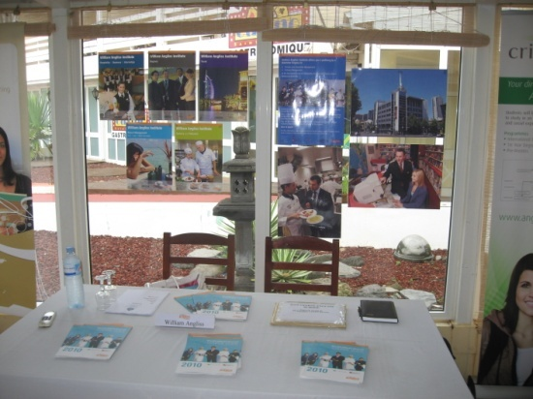
- Undertaking general internet research. This is an excellent source of information as it quickly brings the world straight to your door and readily shows you things as well as providing simple text
- Developing, distributing and analysing questionnaires. This is a paper-based or electronic variation on verbally asking questions. The production of a questionnaire will enable formalised feedback to given questions or topics
- Attending conferences and seminars. Anytime there is a conference or seminar on tourism and/or hospitality you should make an effort to attend. The key is to become involved and be an active participant
- Attending launches of new products or services and openings of new venues or attractions. Many local areas will launch a new tourism initiative and it can be very informative to be there when these initiatives are revealed to the public. There is usually significant media involvement in these launches
- Attending Industry Association functions. These functions are a good networking opportunity and usually feature many representatives from support and associated businesses
- Participating in familiarisation activities. Familiarisations (or ‘famils’) are tours of venues and attractions conducted by the operator to familiarise industry workers, media or potential customers. A famil tour at a venue will include a tour of the venue, viewing of rooms and facilities, a talk by the manager and probably a free meal. At a theme park the famil tour would include free rides, entry to shows, a talk by the manager, participation in shows and tours and also a free meal.
- The idea of ‘fam tours’ is that you can return to your workplace and then tell customers/guests from first-hand experience exactly what the venue/attraction is like and what it is like to go there.


Keys to research
To get the most out of research designed to update local knowledge:
- Do it regularly – it should be on-going
- Take notes – never rely just on memory
- Obtain hard-copy material – pick up brochures, download and print internet sites, file magazine articles
- Involve others. The benefit of involving other people seemingly multiplies what you learn
- Share your findings – pass on new information to both colleagues and customers.

2.2 Share updated knowledge with customers and colleagues, as appropriate

Introduction
Any new or updated local information must be shared with colleagues and customers in order to enhance service delivery and optimise customer experiences.

Sharing local knowledge with customers
‘Customers’ include guests, friends of guests and visitors generally. They can be individuals, families or groups of business people or tour groups.
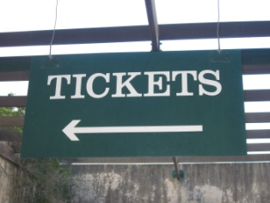
The basics of sharing local knowledge with customers include:
- Advising of altered conditions when talking to customers, guests and visitors. These ‘altered conditions’ may relate to:
- Opening hours for a venue/attraction, park or business
- Prices to enter, cost of tickets and tours
- Schedules and timetables of shows, buses, trains
- Mentioning new options to customers/guests such as:
- Telling them about a new park, gardens, attraction
- Giving them a brochure about the new or revised attraction
- Providing a map and directions about how to get there
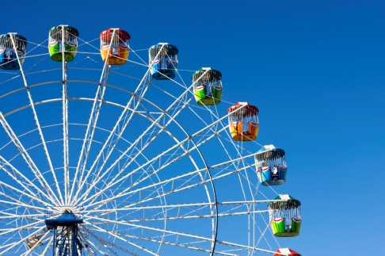
- Asking people where they have already been and what they have already seen so you can:
- Recommend attractions and local destinations they have not yet seen
- Provide them with information/brochures about those places
- Give them your first-hand impressions about the attraction or destination, where applicable
- Prepare local ‘information packs. These can simply be an assortment of information brochures relating to different types of places of interest, types of tourism, guest interests and local information or statistics
- Develop a series of tours suitable for guests or visitors. These should be supported by relevant information brochures, schedules and maps and encompass:
- Walking tours, self-drive tours, public transport-based tours
- Two-hour tours, half-day tours and full-day tours
- Night walks.

Sharing local knowledge with colleagues
Techniques for sharing local knowledge with colleagues was presented in Section 1.4.
The keys were:
- Verbally tell your colleagues about what you have learned
- E-mail co-workers with the information you have discovered
- Prepare and distribute a handout
- Update internal information systems
- Replace and replenish internal displays
- Arrange for a guest speaker to come and talk to staff
- Organise a visit to the venue/attraction.

2.3 Incorporate the sharing of local knowledge into day to day working activities

Introduction
It is critical for all venue staff to incorporate the sharing of local knowledge and information into day to day working activities.
This Section identifies some ways this may be done and also highlights a very common mistake you must ensure you never make in relation to providing local information to visitors/guests.

Ways to incorporate local knowledge into daily activities
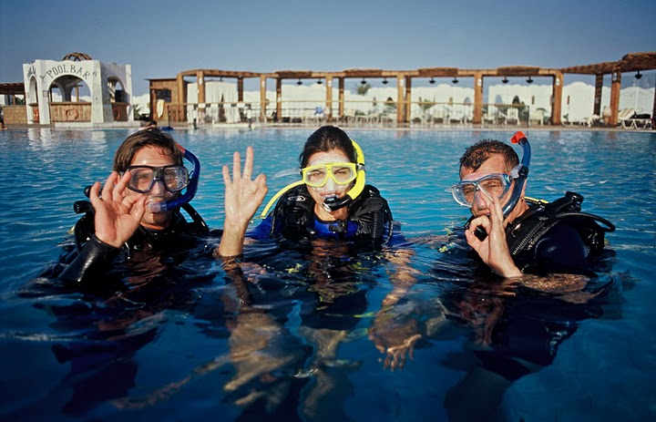
Some of the following have already been mentioned but this Section expands on and reinforces the information presented previously:
Prepare a few local trips for your visitors
It will not take much for you to put together a few trips around the local area to enable guests/visitors to experience what the local area has to offer and guests are sure to be appreciative.
Remember the key aims of doing this are:
- To try to get the guest to stay another day or more
- To maximise their enjoyment during their stay in order to bring repeat and referral business.
There are usually three trips worth organising – the full-day trip, a half-day trip and the ‘two hour’ trip.
The full-day trip should spell out:
- The route to take

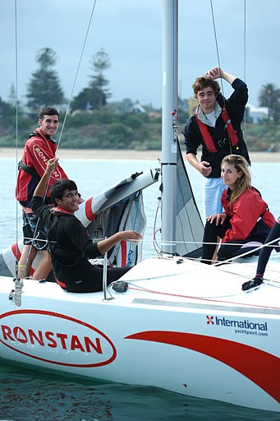
- The distances involved
- The times allowed for
- Details of all the destinations you have planned for people to see. You would aim to put together as many of these types of trips as you can. There may be subtle changes between similar trips based on different opening days/hours for some attractions. For example, your area may have certain attractions not open on Tuesdays and Wednesdays.
Half-day trips should aim at a four-hour trip. You may have different ones for different days, for example, because some places may not be open at certain times, or the animals are only fed at 4:00PM, or the tide comes in at a certain time. There may be different ones for the morning and afternoon.
You may even prepare different ones for different weather conditions.
There may be different ones for different seasons especially where natural attractions are involved.
Night walks are a fairly common extension of this concept.
The ‘two hour’ trip is for those people who want to squeeze a little bit extra in today, or before they depart the area tomorrow. The same advice as for the other types of trips applies except the trip is just shorter. You may be able to divide a half-day trip nicely into two, or it may be a totally new idea.
It is a good idea to create one of these trips between your venue and, for example, the airport so the guest/visitor can a little bit extra on their way ‘home’.
These ‘trips’ can be ‘mud maps’ with hand-written features or you may produce them on your workplace computer and printer. You may elect to take them to a professional and have them professionally produced and printed for distribution.
Naturally the itinerary you prepare should be certain to describe any potential pitfalls, dangers, obstacles, hazards, or warnings. It should also list any items people should take with them. This may include petrol, sun screen, drinking water, coins for machines and/or need for a hat.
Depending on your clientele, you may prepare trip handouts in different languages to cater for the cross-section of international visitors your venue attracts.
Develop a special ‘local information’ list
If the local Visitor Information Centre does not already have any suitable lists accommodating this need, then it is up to you to provide the information.
Make up your own list to help visitors.
Do this job properly and make a big production out of it. Make your establishment a central feature, but be prepared to sell space to other operators who are likely to benefit to help defray the costs of production. Who knows, you might even show a profit out of it, and get free advertising for your property too.
It will be your decision what is contained in the list, but the above notes provide a good starting point: local attractions, tours, opening hours, costs and distances.

Tell all guests, customers and visitors about what you know

This should include:
- Involving all front of house staff in telling customers what is available. This can include:
- Reception staff on guest arrival
- Waiting staff in dining areas
- Bar staff in bars
- Making it standard procedure for staff to ask customers/guests what they have seen or done so they can then recommend something they have not seen, and something they have not yet done
- Providing relevant support materials such as maps, brochures, promotional materials to optimise the chance of customers/guests taking up suggestions made by staff
- Using personal experience as the basis for making suggestions. Telling customers of your own experience at the attraction or on the tour gives a ‘personal’ and first-hand touch which commonly makes the difference between whether a guest takes up the suggestion or not.
Inform regular visitors personally on arrival
If you know a regular visitor/guest is arriving tomorrow and you know, for example, that they love to go fishing in the local tidal river, then make sure you or the receptionist hands them:
- A current copy of the tides and times
- A current price list of the boat hire charges from the local hire shop.
What service, what a welcome!
The same idea applies for any regular visitor where you know their tastes, preferences and hobbies.
Go ahead and make the extra effort.
It often will not take much to stand out from your competitors because all too often they do nothing so it does not take much to beat them in this regard. You just need to follow through and take the necessary action.
Maintain your internal files
This is sometimes overlooked and providing out of date information can cause much confusion and disappointment. In some ways, giving guests dated information is as bad as, or worse than, providing nothing at all.
After the initial enthusiasm about creating a local information ‘system’ or file, there is often a drop in attention given to maintaining the information. Staff sometimes become less than dedicated and the files are not updated as things change and/or new information is sourced.
It is therefore very important to appoint someone, perhaps on a cyclical or rotating basis, to be in charge of local information updates and filing. When a new price list, brochure, flyer, or catalogue comes in this person must throw out the now superseded one and replace it with the up to date copy.

If a new business, venue, tour or attraction opens, this must be incorporated into the existing file/system. You cannot ignore its existence.
This sounds so obvious you probably think it is not worth mentioning, until you find yourself with a price list (or map, or brochure, or tour schedule) dated two years ago and attempting to help a guest. It can be very embarrassing and it reflects poorly on the establishment in general.
Update the displays
As mentioned already, make sure new information is included in any displays, racks or in-room compendiums too.

The BIG ‘No-No’
There are lots of pieces of information a tourist or visitor could potentially ask for and in reality it is rare for anyone to be able to answer every enquiry from every person. You are never, therefore, expected to know everything about everything.
BUT you are also never expected to just answer an enquiry you do not know about with a silly grin and the words ‘Sorry, I don’t know’.
If you do not know, it is acceptable to say so but you must then take appropriate action to follow-up, find out and get back to the visitor with the required information. This may involve:
- Making a phone call to the actual attraction or hotel they are making enquiries about, or phoning the Visitors Information Centre
- Asking someone else if they know. If you do not know there may well be another staff member who does know and who may be able to help
- Referring to your library of tourist information. This could assist with finding out, for instance, prices, and the finer details (such as opening times, credit cards accepted).

Remember – tourists are not locals!
It is very easy for people who live in a place to forget visitors and tourists do not have the same ‘local knowledge’ they have.
As locals you often take much knowledge for granted and most of this information is information tourists and visitors do not have.
You have to always be on your guard about ‘assuming knowledge’. That is, assuming the tourist knows basic information you know that you have grown up with.
Most tourists do not understand the subtleties of the local culture and will be unfamiliar with many things you automatically know. The main point is that it never hurts to check with tourists/visitors that they fully understand and appreciate even the basics of your society and culture.

ALWAYS bear in mind that many visitors/guests are in a strange place and desperately looking for a friendly face and help. Help often takes the form of:
- Talking to people
- Smiling
- Offering to help
- Providing advice and information
- Showing an interest in them as individuals.
Work Projects
It is a requirement of this Unit that you complete Work Projects as advised by your Trainer. You must submit documentation, suitable evidence or other relevant proof of completion of the project to your Trainer by the agreed date.
2.1 Provide evidence (that is, hard copy materials discovered as part of the research process) of formal and informal research you have undertaken to update your current/existing local knowledge.
2.2. Prepare and submit a report providing evidence of ways in which you have:
- Shared local knowledge with visitors
- Integrated the sharing of local knowledge into day to day workplace activities.

Summary

Update local knowledge
When updating local knowledge:
Be active – never expect information to come to you: you have to go and get it
Use formal and informal research techniques to source local information
Organise familiarisation tours of local venues and attractions
Do research on an ongoing basis. You cannot research local information once and believe that is all there is to it
Take notes about information you discover
Share new and/or revised local information with work colleagues so they too keep up to date
Integrate new/revised local knowledge into activities designed to enhance visitor experience, and encourage repeat and/or referral business
Tell visitors about new/revised local information. Never wait to be asked. Be proactive in sharing local knowledge with everyone
Develop a suite of local tours for visitors to enjoy – 2-hour, half-day and full-day trips
Develop a list of local contacts you can turn to in order to help visitors with extra need for local information
Involve all customer contact staff in providing local information to visitors
Never reply to a visitor request for information with a simple ‘I don’t know’ – find out, and pass the information on
Always remember the need to be friendly and helpful to all tourists and visitors.

Element 3:
Maintain contact with local communities

Background
What is a local community?
In order to develop and update local knowledge effectively it is necessary to be proactive.
Part of taking the initiative in this regard is the need to maintain contact with local communities. ‘Local communities’ can include:
- Other businesses in the area
- Local groups, clubs and interest groups who conduct events and/or support local tourism initiatives
- Individuals who are active in promoting the local area.
In brief, anyone or any organization involved in organising local events or operating local businesses or attractions can be seen for the purposes of this unit as a ‘local community’.
How can I maintain contact with local communities?
The key to staying in touch with local communities is to apply a mix of the following activities:
- Join local groups and attend their meetings
- Participate in what local groups are doing and contribute assistance, information and resources to help them achieve outcomes that are mutually beneficial
- Contact them on a regular basis. Visit them face to face or telephone them regularly
- Ask them to contact you. Encourage them to contact you and make it easy for them to do so. Let them know you want to maintain contact with them
- Thank them whenever they contact you. This encourages them to keep in contact
- Offer your venue as a meeting place to keep your venue firmly centred in their minds.

3.1 Provide accurate local tourism information in response to queries

Introduction
It is important to provide accurate responses to all tourist queries.
This Section looks at whose job it is to provide this information, elements of an effective response and an overview of topics you might consider when developing your own personal local knowledge to assist visitors.

Elements of an effective response
When a visitor, customer or guest asks you a question related to local knowledge, it is important your response is:
- Honest – never tell an untruth or a half-truth about anything.
Never say something is ‘good’ or ‘worth seeing’ unless you genuinely believe it to be the case
- Comprehensive – never tell a person ‘only the good bits’. If there are bad aspects to what you are providing then you must ensure these too are presented and explained.
For example, if the tour is excellent but it is hot and dusty you must tell the people it can be hot and dusty
- Up to date. All details about all aspects of the response (costs, times, opening hours, displays on show, animals) must be current.
- Relevant. It is your job to add any information you know about that relates to the query but which has not been specifically asked about.
For example, if you know the attraction you are suggesting to people does not have credit card facilities, EFTPOS or ATMs then you must make sure you tell people they will need to take cash with them when they visit
- Timely. All responses must be given in a timely manner.
In practice this means ‘straight away’ subject to the need for you to make enquiries (such as making a telephone call, or looking at an information database) on behalf of the tourist to determine specific information they are seeking.

Whose job is it?
The provision of local and venue information to visitors and guests is everyone's job.
Your venue may have a reception desk, concierge, and/or information counter but it is still the role of every employee without exception to provide accurate and up to date information to anyone who requests it.
By providing such a service the establishment is better able to attain the twin goals of providing excellent customer service and exceeding guest expectations.
No-one expects everyone to know everything there is to know about all the local attractions, events, transport options, general visitor facilities including shopping, currency exchanges, post offices, banks and emergency services. However, all staff must have at least substantial general knowledge about the local area.
In addition staff must know where to go to obtain more detailed information if required.

Identify and obtain commonly requested information
Every venue will have individual needs regarding information guests/visitors are likely to want. Many of these pieces of information are dictated by the physical and geographic location of the venue.
The information required in a tourist destination will quite obviously be different to the information needed by guests in most other locations.
Guests/tourists at a tourist destination will seek information access to the attractions (routes, distances and time to travel), opening hours, viewing times, show times, where to purchase tickets, cost of tickets and entry and so on.
Guests and visitors in a city environment, by contrast, may require advice about live theatre, public transport, location of certain shopping and dining precincts, guided tours of the city, CBD facilities and sporting venues.

Guests/customers in a regional or remote area may focus their questions on four-wheel drive tours, natural attractions, old buildings, historic landmarks, local museums, trips to meet ‘the locals’.
Other local information you need to know about
In addition, the range of local information required may vary according to the particular workplace. Information can be expected to cover:
Enterprise specific information
Also known as 'product knowledge' this covers details about the venue.
Topics about which you should be able to provide information include:
- When certain facilities (swimming pool, gymnasium, spa, bars) are open
- Prices for everything the venue has to offer: drinks, meals, rooms, services
- How to make a booking for a room, dining reservation or the tennis courts
- Check-out times
- Arrangements for parking.
Local transport options
Staff must have a basic working knowledge of what is available including:
- Transport options especially trains, trams, buses but also taxis, hire cars and other more local alternatives such as tuk tuks, rickshaws, trishaws, pedal bikes
- Cost
- Where the station and bus stops are
- Frequency of public transport (buses, trams and trains) supplemented by current timetables. More detailed information should be in the in-house file together with contact details enabling even more detailed information to be accessed when required.
In some locations, transport options can include all manner of modes of transports from canoes, to camels to four-wheel drives. They can include buggies, horses, motor bikes, scooters and push bikes. They may cover motor boats, ferries, airplanes and helicopters.
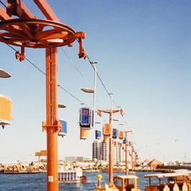
Local attractions
This must address:
- What is available
- How far away it is
- How long it will take to get there and return using a variety of commonly used transport options
- What there is to see when they get there – displays, animals, activities, rides, tours
- How much it costs to enter the attraction, to go on a tour and to buy tickets for the rides or shows
- When it is open and when it closes.
This information should cover the man-made and natural attractions.
Where the natural attraction conceals or contains some sort of danger this must be highlighted. The danger may be information about wandering stock, wild animals, the possibility of dehydration, and the length (in terms of metres/kilometres and in terms of time) of walks.
Local customs must also be addressed so visitors do not give unintended offence to the locals.
Local events
These are often the reason visitors come to an area and you must ensure you do everything in your power to support them in achieving their tourist aims and objectives
You must develop a comprehensive list detailing all the annual local events. The Visitor Information Centre will help with this as they will traditionally already have such a list published.
You may elect to enhance this list and add more details, more information or more advice. This is all designed to attract visitors and convince current tourists to see and do more (that is, stay an extra night or two).
You may decide to further explain the particular event by explaining what it is all about, who it attracts, costs, duration, and special points of interest.
In some cases you may also supply details about how visitors/tourists can participate in the event, if that's what they want to do, and how to get the most out of attending the event or festival.

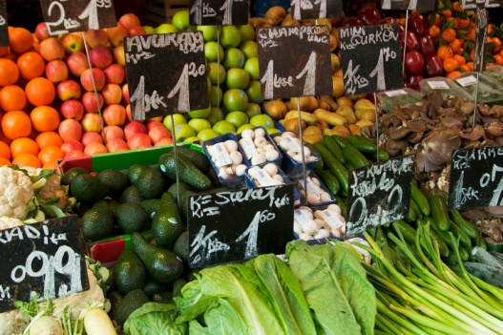
General visitor facilities
Your in-house local information file should contain information about:
- Shopping locations
- Currency exchange sites
- Post offices
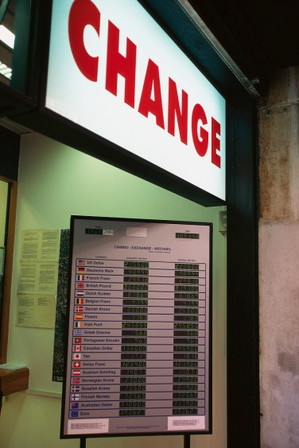
- Banks and ATMs
- Emergency services.
Unfortunately very few of the above have pamphlets or brochures so it will be up to you to seek out and record the relevant information.
Your own personal local knowledge coupled with use of the telephone and a visit to the Visitor Information Centre should be sufficient to source all the details you need.
Many establishments will also subscribe to a "This Week in …" publication carrying much relevant information and other tourist-related information.
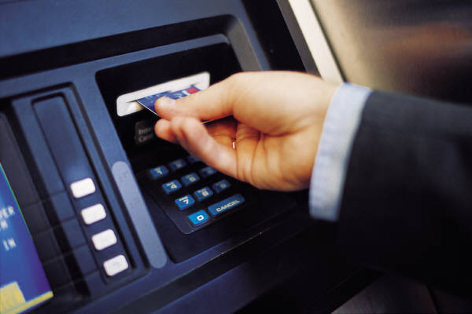
Dining
Hopefully most of your guests will dine in-house (and you certainly must be alert to selling your dining facilities to visitors) but frequently you will be asked "Where's a good place to eat?", "Is there a good Indian restaurant in town?", or "Where can I get a quick takeaway?"

Your local knowledge comes into play here and it is a good idea to get some more information from the person asking the questions before you make a recommendation. For example:
- Do they want a quick meal, or a full night out?
- How much do they want to spend?
- Do they have transport?
- Do they want a ‘local’ experience?
When you have this sort of information, you can then make an informed suggestion. It is great too if you can go to your filing cabinet and bring out a copy of the menu for the place you have recommended! What service! What a concept!
Your file, then, will need to cover dining facilities such as cafes, restaurants (of all types, classes and styles), takeaways, places that do home deliveries, function centres, bistros, and any other style of eating house peculiar to your area or country.

Personal service businesses


This includes a detailed list (name, address, contact details, prices, plus other relevant information as indicated by the precise nature of each business) of dentists, doctors, chiropractors, beauticians, remedial masseurs, podiatrists, travel agents, and computer technicians. You will be surprised how many people travel with a laptop and need occasional but absolutely crucial IT support.
Entertainment
This should cover the widest interpretation possible of 'entertainment' and embrace, as appropriate to your area:
- Theatres
- Cinemas
- Entertainment venues
- Natural swimming spots (beaches, rivers, lakes), beaches and swimming pools
- Local sporting clubs
- Sporting facilities
- Health clubs and gymnasiums
- Golf courses
- Shooting ranges
- Fishing spots
- Tours and tour organisers.
Travel
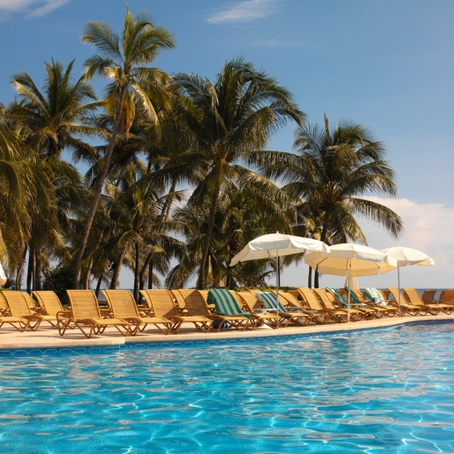
In many locations (both metropolitan and regional), visitors can require detailed information on the best way to get to a certain location. This might be a tourist destination for a day trip or their next port of call.
A road map or street directory can handle the majority of queries, but in the more remote areas, guests may require information about road conditions, which roads are impassable and where to go to get up to date information on this.
The local police and the road service clubs are a good start together with local input from the service station.
Weather
Again, this often depends on the geographic location of the venue (sometimes coupled with the season or time of the year), but you may be asked to provide information about weather conditions.
This may especially be the case where you are situated near the sea and guests want to do a sea cruise or go fishing. You may subscribe to a Bureau of Meteorology (or similar) service designed to provide fee for service weather and tidal information.
Some venues will have a board in the foyer with weather forecasts.
Local visitor guides
These are one of the most asked for items of visitor information.
Contact your local Visitor Information Centre and ensure you have enough of these to:
- Put in guest rooms
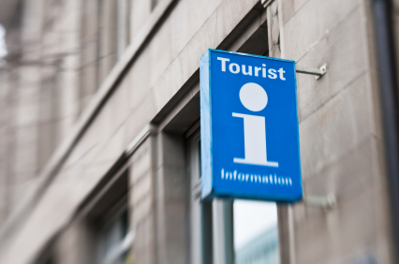
- Display in public areas
- Distribute from the reception desk.
Local people
This can be a valuable resource for tourists and visitors.
You, or others, will know of many excellent local 'contacts'. These can be people who are in the know about certain things, people who have been in the area for years, people who know the ins and outs of the local scene and are aware of all the local happenings.
They may be local identities, business people, pillars of the society, people newly arrived to the area or those who were born and bred in the area.
They may be the president of the local fishing club, secretary of the local service club, or a member of a local organization.
Get their permission first before you put them on the list. The list is not for public distribution but simply one you can use to source specific information about issues as questions arise.
Most people will not mind being included – many even consider it a bit of an honour.
Government rules and regulations
It is a good idea to have a comprehensive list of information detailing the legislated requirements applicable to your country/area in relation to:
- Taxes payable by tourists and rebates (where applicable)
- Prohibitions on goods that can be taken out of the country
- Documentation required to take nominated items out of the country
- Immigration and visa requirements.

3.2 Use local knowledge to promote tourism products and services to encourage usage and purchase

Introduction

When using local knowledge to promote tourism products and services you must remember:
- You must be proactive
- The aims of promoting tourism products and services are to:
- Enhance the tourist experience
- Encourage tourists to stay another night or two in the area.
This Section describes what is involved in being proactive, identifies what is meant by ‘tourism products and services’ and reinforces the reasons why tourists/visitors should be encouraged to purchase these items.

The role of local knowledge when promoting local tourism products and services
You must always use local knowledge when promoting local tourism products and services because:
- The local knowledge you pass on to tourists, customers, guests or visitors often decides whether or not the person has an enjoyable experience or not. This is a prime consideration in determining if those people generate return or referral business from the venue and/or the area or country.
Local knowledge ‘enriches’ the tourism experience.
- Local knowledge enables the tourist/visitor to differentiate themselves from other tourists/visitors who do not have ‘local knowledge’ and hence cannot avail themselves of the benefits this local knowledge brings
- Sharing local knowledge is an excellent way of demonstrating your acceptance of the visitor/tourist. In many ways sharing local knowledge is like sharing a secret and there are many positive attitudes and orientations implicit in the simple act of passing on such information.
By sharing local information you are:
- Demonstrating respect for the other person and regarding them as ‘an equal’
- Proving you want to provide a memorable experience for the person
- Deeming the other person as worthy of the secrets you have
- Allowing the other person an insight into your country and culture they would not otherwise have
- Sharing local knowledge is often the local experience. Without this local knowledge there would be little or no ‘local experience’ for the person to remember and talk about after they have departed.

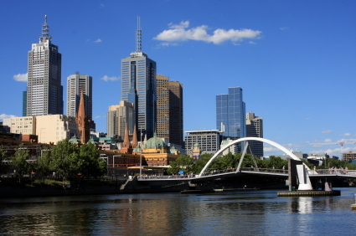
Examples of the use of local knowledge
You can use your local knowledge to:
- Tell visitors the latest information about the area or an attraction
- Advise them of the best or quickest way to get to a destination
- Inform them of traps, pitfalls and cons to avoid
- Compare one option against another
- Let visitors know where the locals eat, swim, fish, relax
- Indicate the best time of day to visit an area, landmark or feature
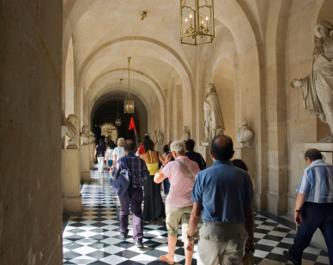
- Explain what constitutes best value for money locally
- Identify the best restaurants, bars, shops.

Being proactive
In terms of using local knowledge when promoting local tourism products and services you must:
- Offer the local knowledge/information without having to be asked. This means you share what you believe to be local information with those who might need or benefit from it without waiting for them to ask for the information or advice .
If, for example, a tourist has asked about a local tourist attraction and you know there is an additional and interesting destination on the way to that attraction you should tell them about it, how to get there, and what the additional destination is all about
- Making suggestions about what tourists/visitors can do with their time by:
- Asking what they have planned for the day
- Asking what they have already done. This identifies local things they have not done, or local sites they have not visited
- Developing 2-hour, half-day and full-day tours – see earlier notes at 1.2, 2.2 and 2.3
- Showing enthusiasm for the suggestions you make. You cannot successfully convince another person to visit an attraction or take a tour unless you are 100% committed to how much fun it is, what a unique experience it is or how sad it would be for the person to be close to the attraction and not get to see and experience it.
Implicit in this is the need for you to have pride in your country and local area.
In very many ways you are an ambassador for your region, country and your venue
- Talking to people after they return from a trip or experience you have suggested. This means asking them how they enjoyed it, and what they learned.
This conversation is also important because it provides you with feedback about whether or not your original recommendation should be repeated to other visitors or not. It is also provides feedback about what may have changed at the destination you recommended.

What are tourism products and services?
There is no strict definition of exactly what constitutes ‘tourism products and services’.
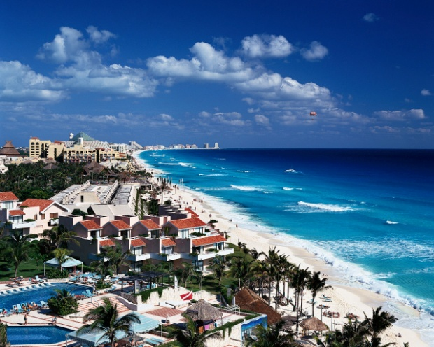
From a practical viewpoint, the term should be interpreted in the widest possible context to embrace anything the venue and the local area has for sale.
Some will insist ‘tourism products and services’ refers more particularly to items (products/goods and services) specifically aimed at tourists, such as:
- Attractions
- Destinations
- Accommodation
- Tours and trips
- Landmarks and places of interest
- Transportation
- Specialist areas of interest for groups/tourists such as nominated shopping precincts, sporting events, religious festivals or local celebrations.
In reality, however, anything a tourist purchases or uses can be described as a tourist product or service. This can extend significantly into countless items where an on the spot demand exists for many quite ‘ordinary’ items such as:
- Cell phone cards
- Petrol
- Meals and drinks
- Pharmaceutical products
- Cigarettes
- Items of clothing.

Reasons to promote local tourism products and services

There are a large number of reasons why all hospitality and tourism staff need to promote and encourage the use of local tourism products and services.
Some reasons are personal, some are venue-specific, some are local/regional and some are national.
Promoting local tourism products and services:
- Meets visitor/tourist expectations. It could be said if you do not promote local products and services you are doing a dis-service to customers
- Provides better job satisfaction

- Enhances job security and enables extra hours to be worked by you and others
- Identifies you as someone trying to help visitors and may identify you as someone with the potential for promotion or career advancement
- Allows you to learn more from other people and creates the potential for a greater network of contacts
- Increases the possibility of tips and gratuities
- Demonstrates your venue is a good corporate citizen by sharing wealth and opportunity
- Assists your workplace maintain its ongoing viability by generating extra revenue and repeat and/or referral business
- Supports local businesses and the local community by generating income for them which maintains local industry and sustains employment
- Enhances visitor/tourist enjoyment of the local area/region
- Shares the local culture with visitors enabling better appreciation of the country/region amongst visitors/tourists
- Gives greater insight into, and understanding of, the people and the country to overseas visitors.

3.3 Make customers aware of possible extras, add-ons and further benefits

Introduction
When sharing local knowledge with visitors/tourists an opportunity regularly exists to make these people aware of possible extras, add-ons and other benefits.
These opportunities should be taken whenever possible to optimise guest/customer satisfaction and enjoyment, and maximise sales.
This Section identifies factors to take into account in this regard and provides examples of possible add-on sales that may be made.


Effectively suggesting extras and add-ons
The keys to effectively suggesting extras, add-ons and features to visitors and tourists include:
- Establish a rapport with the visitors/tourists. This facilitates the exchange of ideas, questions and information.
It increases the trust between the parties and encourages people to ask you questions and to ask for advice
- Make use of your local, venue and product knowledge. The advice or information you provide must be based in fact but overlaid with personal opinion and recommendation


- Be positive and approachable. You have to be seen by tourists and guests as someone who will help them, who is prepared to spend some time with them and who wants to share what they know.
Open body language and smiling are important assets in this regard
- Use polite and respectful language when communicating. The idea is to include the visitor in the conversation without making them feel they are silly for asking questions, or are being ‘spoken down’ to
- Apply questioning and listening skills. It is always useful and important to find out about the interests, needs, wants, preferences and constraints of people before providing local knowledge and/or advice on add-ons and extras.
For example, are they interested in theme parks or natural attractions? How long do they have? What have they already done or seen? How much do they have to spend? How would they prefer to travel?

- Match suggestions to identified needs and parameters. If the visitor demonstrates an interest in theme parks it is inappropriate to start promoting the add-ons associated with visiting the local zoo. Talk about the extras, add-ons and benefits allied to what you know about the local theme parks. For example mention the benefits associated with pre-purchasing ride tickets, entry tickets and tickets to shows/displays.
If the tourist only has half a day, there is little point suggesting the benefits associated with a full-day tour
- Know when to stop. Be alert to the potential for visitors not to want to be given information about add-ons.
Recognise these verbal and non-verbal cues quickly and stop ‘promoting’. Insisting on trying to sell extras can only be counter-productive in these cases
- Explain the characteristics of the add-ons and extras. These are the tangible factors related to the product or service: see below ‘Examples of possible extras and add-ons’
- Describe the benefits of the add-ons and/or extras. These commonly relate to cost and time saving: see below ‘Examples of possible extras and add-ons’
- Tell the truth. Never adopt the belief your job is to make a sale ‘at any cost’
You must always be honest in everything, including telling people about any potential down-sides of a suggestion you might make
- Never put pressure on people to buy add-ons or extras. Your job is to make people aware of options and give them advice. Your job is never to try to force people to purchase add-ons or extras.

Examples of possible extras and add-ons
The type of add-ons and extras you might suggest to customers or recommend to tourists will vary depending on your location/region and on the identified needs of individual tourists.
It is, therefore, impossible to identify every possible add-on or extra so the following is an indicative list you must adapt to suit your own situation and the requirements of individual customers.
The important thing to remember when attempting to sell add-ons and extras is to promote complementary products or services according to identified tourist/visitor need that will bring enhanced value or benefit to the individual.
The following are examples:

- If the visitor has indicated they want to participate in a local tour you may try to sell them a different tour (a more expensive one) to what they originally indicated they were going to undertake because it enables them to benefit from tangible elements such as:
- It is a much longer tour – an extra day, two hours or twenty minutes
- It covers more things. For example, they might:
- See more animals
- Experience more shows
- Participate in extra activities
- Have access to restricted areas
- It gives them more products such as perhaps:

- Merchandise – cap, T-shirt, pen
- A photograph of them with animals, standing in front of a monument or on a chair lift
- Explain the benefits (as opposed to the physical characteristics) of the add-ons and/or extras. These may include:
- Pre-purchasing a certain ‘package’ may mean they do not have to queue on arrival at the theme park or zoo to gain entry (time saving)
- Buying a book of tickets means the cost of each ride is cheaper (cost saving)
- Purchasing a tour means elements of the tour/packages are bundled and they receive better value for money (cost saving)
- This particular tour is only available at this location and nowhere else in the world (making it ‘unique’ and giving it prestige)
- Your local knowledge can also be used to advise people regarding their purchases by recommending a certain ‘add-on’ or ‘extra’ because:
- It will give them a better view. For example, buying a higher-priced seat may mean the tourists are not looking into the sun, or they are sitting in a shaded area
- It will enable them to have greater engagement with different people or animals or experiences or sites
- The offering is only available today, this week, this month, this season, this year
- The more expensive 4:30PM tour is better than the 10:00AM one because the later tour includes the feeding of the animals
- Taking the cable car to the gardens will provide a spectacular view over the bay, the mountains and the city and it avoids heavy local traffic congestion.

3.4 Report queries and results to designated person within enterprise for follow-up purposes

Introduction
It is standard operating procedure in most venues for staff who have face to face contact with customers/guests to provide feedback to management about their experiences involving visitors/tourists especially as they relate to the questions they ask and the result of information provided to them.

This Section explains why this feedback cycle is necessary, identifies who is likely to be involved and illustrates how this feedback may be followed-up.

Queries and results
Queries
In this context ‘queries’ relates to any questions asked by customers, guests, visitors and tourists about:
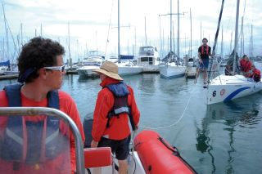
- Local events and/or attractions
- What they can do and where they can go while staying at the venue or area
- Local options for tourism activities, tours, displays, meetings, shows or displays
- Local transport and local facilities
- Local products and services.
In essence, any question asked by a visitor can be regarded as a ‘query’ for the purposes of this Section. Even a basic type of question (such as when the dining area is open) is a relevant query as it indicates a need for the venue to be able to supply this type of information.

Results
‘Results’ refer to the effectiveness of the response given by staff to visitors who asked questions.
The effectiveness should address issues such as:
- Was there a communication problem? For example, was a difference in language a problem preventing effective communication?
- Could there have been a better option for providing the information? For example, would it have been more effective to have given the guest a map rather than verbal direction?
- Was there a lack of knowledge about the question? This may indicate a need for the venue to capture more information on the topic in question
- How well did the information provided by the staff meet visitor needs, wants, preferences or parameters? For example, when a guest returned to the hotel, did they indicate they enjoyed the tour/attraction suggested by staff, or not? If not, why not? Was it too expensive, too far to travel, too expensive, not interesting or exciting enough, unsafe?

Why is it important to report on queries and results?

It is important for every tourist venue/destination to be actively involved in monitoring the queries of visitors, and the information provided to visitors by venue staff, because:
- This is an effective and inexpensive way of identifying what is important and of interest to our visitors. It is cheap market research
- It demonstrates customer focus. The venue can use the research to better create experiences more appropriately suited to identified customer needs, wants and preferences
- Regular meetings of this nature amongst staff and with management help staff maintain a focus on customers and their needs as opposed to creating a focus on themselves and the venue. The focus must always be on the customers/tourists and what is best for them
- This is an excellent way of sharing information between staff at the venue about what to do, and about what not to do, say or suggest and about what is effective and what is not
- It makes staff accountable. If employees know their actions and recommendations are gong to be fed back to management they will tend to be more responsible, sensible and focused in what they say or suggest
If ‘it’ is good for the visitor, it will ultimately be good for the venue.

The people involved in these reports
Report makers
The people reporting on guest queries and results must include all frontline, customer contact staff.
This will include:
- Reception/front office staff
- Porters and concierge
- Waiting staff – food and beverage
- Bar staff
- Attendants in retail outlets within the property
- Tour guides and tour vehicle drivers

- Ride attendants
- Ushers and Information officers.
Report takers
The personnel in a venue to whom these reports should be made include:
- Owner of the business
- Managers
- Marketing department
- In-house trainers
- Safety and security officers.
Reporting options
The basic options for providing these reports is:
- Written report which often involves completion of a pro forma document to ensure relevant items are covered, and to speed up the process
- The written report may be delivered in hard copy form, or electronically forwarded via the intranet
- Verbal report on a face to face basis either one on one or in a group setting such as a staff meeting, briefing or training session
- A combination of the verbal and written feedback. This is arguably the most effective and informative but is also the most expensive and time consuming.

Internal action and follow-up
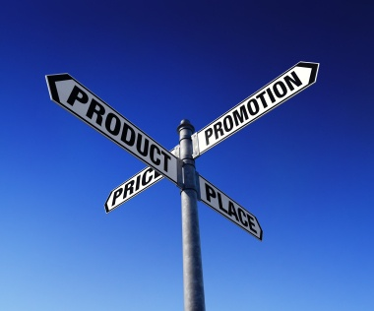
The action to be taken or follow-up required will always depend on the nature of queries and the identified results. Possibilities include:
- Staff training which could involve:
- Learning more venue, product and local knowledge
- Learning another language or some useful phrases or words from the language of another country from which lots of your visitors come
- Learning how to more effectively question and/or listen to people to better identify their needs
- Revisions to standard internal training materials and content
- Revising the suggestions, recommendations and information to be given to visitors
- Revision to standard materials available at the venue. For example:
- Obtaining more or different brochures, flyers, maps, schedules and/or price lists
- Updating materials identified as being out of date in displays, behind reception, at the concierge desk and in the room compendiums
- Creating materials to meet an identified need where no other materials exist
- Introducing, changing or removing products and services:

- To better meet identified need
- Notifying sales representatives and commission agents about changes
- Promoting the new/revised products, services or packages and inclusions
- Changing venue advertisements:
- In order to better target identified needs, wants and preferences
- In terms of online advertisements, brochures for the venue, media advertisements and entries in travel books and with Visitor Information Centres
- Apologies to customers which may involve:
- Verbal or written apology
- A refund or substitute product or service or a discount or special offer for another product or service.
Remember, the above is not an exhaustive list. The important thing is to take action, follow-up and/or make changes in response to identified issues, problems and opportunities specific to your particular venue.

Work Projects
It is a requirement of this Unit that you complete Work Projects as advised by your Trainer. You must submit documentation, suitable evidence or other relevant proof of completion of the project to your Trainer by the agreed date.
3.1 Record yourself in an actual or simulated situation in your workplace demonstrating you are able to:
- Provide appropriate responses to visitor queries regarding the need for local tourism information
- Use local knowledge to promote tourism products and services to encourage their usage or purchase by visitors
- Incorporate sharing of local knowledge with visitors into regular workplace activities
- Make visitors aware of possible extras, add-ons and further benefits associated with the purchase/use of local tourism products and services.
3.2. Prepare and submit a report:
- Describing how your workplace captures feedback from staff regarding queries and results in relation to local knowledge
- Identifying one issue involving the provision of local knowledge to a visitor that required follow-up action by management or by the venue, detailing why the follow-up action was necessary and what form it took.

Summary

Maintain contact with local communities
When maintaining contact with local communities:
Provide information and responses to tourist/visitor queries that are honest, comprehensive, current, relevant and timely
Realise it is everyone’s job to provide local information to visitors/tourists
Create a file of information for commonly required local information such as information about the venue, local transport, local attractions, local events, general visitor facilities, dining, shopping, entertainment, the weather, local legislation and regulations
Be alert to the possibilities and potential for using local knowledge to promote local tourism products and services
Be proactive in promoting local tourism products and services. Never be shy about promoting what the area/venues have to offer
Recognise the benefits flowing from the effective promotion of tourism products and services to visitors
Suggest add-ons and extras at every appropriate opportunity
Sell the benefits of any add-on or extra as well any physical characteristics that apply
Match what you try to sell as add-ons and extras to identified visitor need. Talk to them to identify what they want, need or prefer and what, if any, restrictions apply
Never pressure anyone into buying
Provide regular and comprehensive feedback to management and others in the workplace regarding visitor queries and the way in which they have been addressed
Strive to continually service to customers regarding the way in which their queries are dealt with. Be prepared to take necessary action to address negative situations.

Presentation of written work

1. Introduction
It is important for students to present carefully prepared written work. Written presentation in industry must be professional in appearance and accurate in content. If students develop good writing skills whilst studying, they are able to easily transfer those skills to the workplace.

2. Style

Students should write in a style that is simple and concise. Short sentences and paragraphs are easier to read and understand. It helps to write a plan and at least one draft of the written work so that the final product will be well organized. The points presented will then follow a logical sequence and be relevant. Students should frequently refer to the question asked, to keep ‘on track’. Teachers recognize and are critical of work that does not answer the question, or is ‘padded’ with irrelevant material. In summary, remember to:
- Plan ahead
- Be clear and concise
- Answer the question
- Proofread the final draft.

3. Presenting Written Work
Types of written work
Students may be asked to write:
- Short and long reports
- Essays
- Records of interviews
- Questionnaires
- Business letters
- Resumes.
Format
All written work should be presented on A4 paper, single-sided with a left-hand margin. If work is word-processed, one and a half or double spacing should be used. Handwritten work must be legible and should also be well spaced to allow for ease of reading. New paragraphs should not be indented but should be separated by a space. Pages must be numbered. If headings are also to be numbered, students should use a logical and sequential system of numbering.
Cover Sheet
All written work should be submitted with a cover sheet stapled to the front that contains:
- The student’s name and student number
- The name of the class/unit
- The due date of the work
- The title of the work
- The teacher’s name
- A signed declaration that the work does not involve plagiarism.
Keeping a Copy
Students must keep a copy of the written work in case it is lost. This rarely happens but it can be disastrous if a copy has not been kept.
Inclusive language
This means language that includes every section of the population. For instance, if a student were to write ‘A nurse is responsible for the patients in her care at all times’ it would be implying that all nurses are female and would be excluding male nurses.
Examples of appropriate language are shown on the right:
Mankind | Humankind
Barman/maid | Bar attendant
Host/hostess | Host
Waiter/waitress | Waiter or waiting staff

Recommended reading
Corbin, J. & Strauss, A., 2008 (3rd ed’n), Basics of qualitative research: techniques and procedures for developing grounded theory, Sage Publications, Inc., Thousand Oaks, California.
Dawson, C., 2007 (3rd ed’n), A practical guide to research methods : a user-friendly manual for mastering research techniques and projects, How To Books, Oxford.
Fink, A., 2010 (3rd ed’n), Conducting research literature reviews: from the Internet to paper, SAGE, Los Angeles.
TAFE NSW. Community Services, Health, Tourism and Hospitality Educational Services Division, 2001 – 2003, Learner resource: Travel and tourism programs (various), TAFE NSW, Community Services, Health, Tourism and Hospitality Division, Meadowbank, N.S.W., Australia.
Local reading
Information relating to the local area as available in:
- Advertising materials (flyers, pamphlets, booklets and brochures) for local venues, attractions and events
- The series of ‘Lonely Planet’ books as applicable to individual countries
- Local industry and trade magazines
- Local newspapers
- Local telephone books
- Newsletters from local organisations and bodies.

Trainee evaluation sheet

Develop and update local knowledge
The following statements are about the competency you have just completed.
Please tick the appropriate box | Agree | Don’t Know | Do Not Agree | Does Not Apply
There was too much in this competency to cover without rushing.
Most of the competency seemed relevant to me.
The competency was at the right level for me.
I got enough help from my trainer.
The amount of activities was sufficient.
The competency allowed me to use my own initiative.
My training was well-organized.
My trainer had time to answer my questions.
I understood how I was going to be assessed.
I was given enough time to practice.
My trainer feedback was useful.
Enough equipment was available and it worked well.
The activities were too hard for me.

The best things about this unit were:

The worst things about this unit were:

The things you should change in this unit are:

Trainee self-assessment checklist
As an indicator to your Trainer/Assessor of your readiness for assessment in this unit please complete the following and hand to your Trainer/Assessor.

Develop and update local knowledge
 |  | Yes | No*
Element 1: Develop local knowledge
1.1 | Identify and access sources for information on the local area, correctly
1.2 | Identify and obtain information to assist queries on local/national tourism industry, correctly
1.3 | Store and update information according to enterprise procedures
1.4 | Share information with colleagues
Element 2: Update local knowledge
2.1 | Use informal and/or formal research to update local knowledge
2.2 | Share updated knowledge with customers and colleagues, as appropriate
2.3 | Incorporate the sharing of local knowledge into day to day working activities
Element 3: Maintain contact with local communities
3.1 | Provide accurate local tourism information in response to queries
3.2 | Use local knowledge to promote tourism products and services to encourage usage and purchase
3.3 | Make customers aware of possible extras, add-ons and further benefits
3.4 | Report queries and results to designated person within enterprise for follow-up purposes
Statement by Trainee:
I believe I am ready to be assessed on the following as indicated above:
Signed: _____________________________ | Date: ____________

Note:
For all boxes where a No* is ticked, please provide details of the extra steps or work you need to do to become ready for assessment.





